Model HR841

- Start Using：
- 1.1 Appearance and Button Instructions:
- 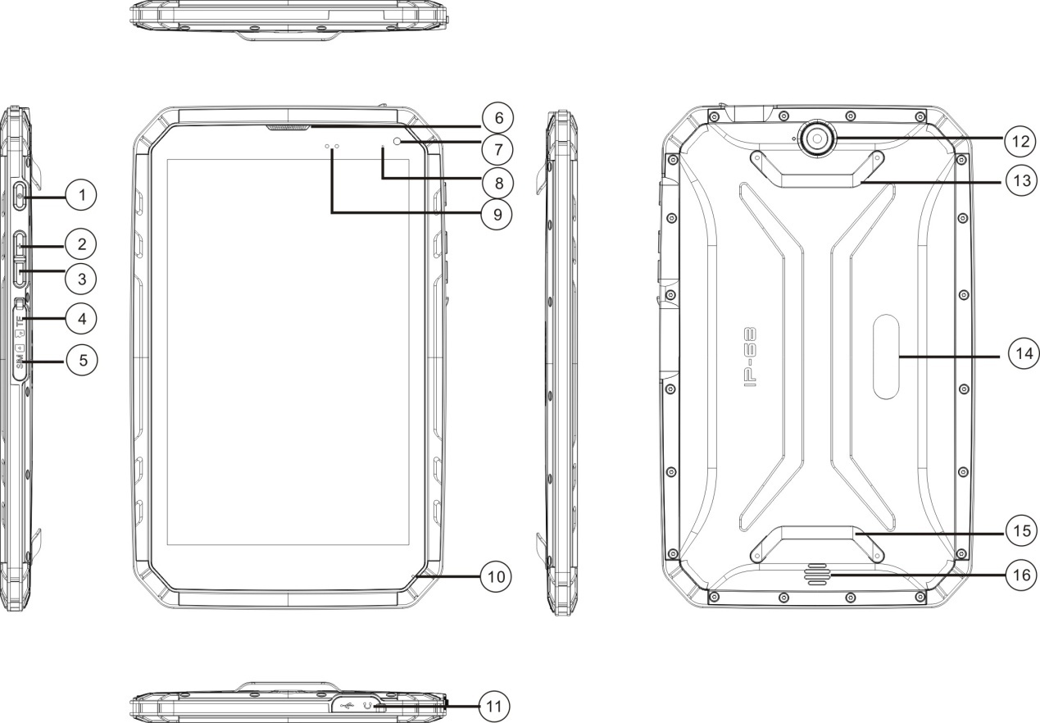
- 1.Power Button； 2.Volume Up+； 3.Volume Down—；
- 4.TF Card Slot； 5.SIM Card Slot； 6.Earphone；
- 7. Front Camera； 8.Indicator Light； 9.L-sensor/P-sensor；
- 10. Microphone； 11.Earphone Jack and USB Charging Port； 12. Rear Camera；
- 13. Belt Holder A (stainless steel)； 14. Brand Sticking Place； 15. Belt Holder B (stainless steel)；
- 16. Speaker

- 1.2 Installation and removal of SIM card/Micro SD card. USB and earphone interface:
- Hold the metal side of the SIM and Micro-SD Card to the right direction and the gap upward and then insert to the correspondent card slot.
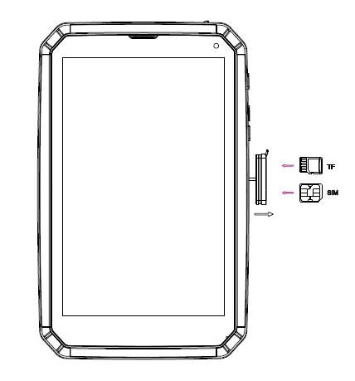

- USB/Earphone interface:
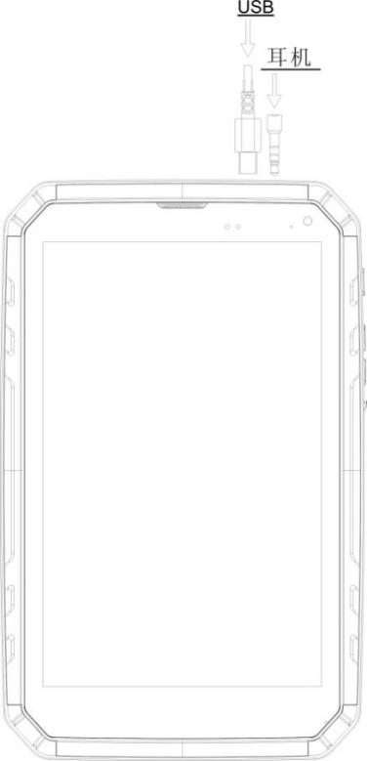
- Please make sure that the battery cover, the battery cover lock, the screw hole plug and the plug of earphone and USB interface are in completed closed condition to make the role of waterproof and dustproof. No more special declarations will be made on this point.
- To install or remove the SIM card, please first turn off this tablet and cut off the connected power supply.

- 1.3 Tablet Specifications.
- Tablet Type | Ultra-slim、IP68, 8” rugged
- Operating System | Windows 10 or Android5.1
- Network | GSM：900/1800 WCDMA：900/2100 or 850/1900
- Dimension | (226.4*142*13.5) mm
- Weight | 665g
- CPU | Intel Baytrail-CR(Quad Core），3735G(F)
- Default Memory Capacity | ROM：16GB OR 32GB RAM：1GB OR 2GB  Micro-SD card storage support up to 32GB maximum
- Display Screen | 8.0''（IPS） Resolution:800*1280
- Network Formats | WCDMA,GPRS,EDGE、WAP
- Battery Capacity | 8300mAh
- Operating Temperature | -20 to 55 Degree
- MMS\Email\Address Book | Support（Address book support groups）
- Video Call\HFT | Support/Support video calls based on network data
- Camera\Video（Video Recording Function） | Front:200W Rear: 800W/500W
- Video Player | Audio Format：SupportpoMP3,3GP,WAV etc. Video Format：Support AVS, JPEG/MJPEG etc.
- GPS | Support
- MP3\Record | Support
- Earphone Interface Type | 3.5mm Earphone
- Sensors | L-sensor/P-sensor/G-sensor
- Water-proofing Degree | IP68

- 1.4 Waterproof Instruction: 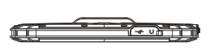

- Tail Plug Waterproof: First cover the trail plug, then please check again to see if it is tight enough to achieve the perfect waterproof effect.
- Preparations before Launching:
- Close the battery cover before launching.(Specifics refer to ‘The installation method of battery cover’)
- Before closing the battery cover, please make sure there is no hair or sand debris surrounding the soft cover which will affect the tightness of it.
- Maintenance after water outlet:
- When this tablet is out of water, please completely dry the body using dry towel or tissue before opening the cover.
- When opening the cover, make sure to open it downward to prevent the water in the slot to go inside the tablet.
- When the equipment is out of water, please wave to dry the water in the speaker, microphone and the receiver. Then place it to dry naturally. Do not dry it with an electronic hair dryer.
- Prohibitions：
- No using in hot springs or hot water. The water-proof flexible glue can’t stand the high temperature so that will let the water go inside this tablet.
- Attention! Do not open the battery cover when the body is not completely dry.
- Do not use detergent or other chemicals to clean this tablet. Use clean water is enough.

- Menu Instructions:
- 2.1 Holding Devices.
- Please do not cover the antenna with your hand or other objects, this will influence the connection with the network.
- 2.2 Volume Adjustment.
- Press the volume button up and down to adjust the volume of the ring or to adjust the volume when playing video or music.
- 2.3 Switch to silent mode.
- Using one of the following methods:
- Press and hold the volume down button till it is switched to the silent mode.
- Press the power button, then touch ‘Silence’ or ‘Vibration’

- 2.4 Power on and off.
- If you want to start up, please long press the power button.
- If you want to shut down, please long press the power button. Then select ‘Power Off’, click ‘Yes’.
- Attentions: In the areas where the wireless devices is restricted to use(such as in the plane or in the hospital), please follow the posted warnings and the staff’s instructions.
- Attention:
- To use the non-network functions of this tablet, please switch to the flight mode.

- Using the Touch Screen:
- 3.1 Click Function：You can click to select an icon or an option in the main screen. For example: Click the dial iron to open the dial function in the main screen.
- 3.2 Press twice: zoom in or out. For example: Press twice to enlarge or narrow the picture or web page when you are viewing.
- 3.3 Long press function: You can get more operating options by pointing the current operating interface, icon or input bar. Such as:
- Long press the icon in the main menu interface to place the icon in the main screen.
- Long press the blank in the main screen to replace the wallpaper.

- Tips of Android Operating System:
- 4.1 Screen Snapshot: If you want to capture a snapshot of the screen by shortcut, try to press the power button and the volume down button at the same time till you hear a sound. Pictures will be found in the gallery after this operation.

- Energy Saving Tips of Android Tablets:
- 5.1 Reduce the LCD brightness to increase the battery working time.
- 5.2 Settings like WLAN, GPS and network data can be turned off if not required, these functions are quite power-consumption.

- Memory Card
- 6.1 Connect USB,click the USB storage devices.
- After connecting the USB, click the message bar and drag it down. Then select to connect to the media device->Media device MTP.
- 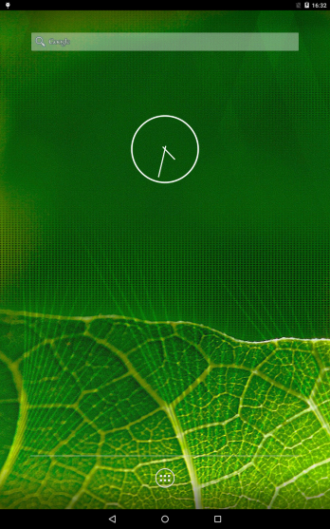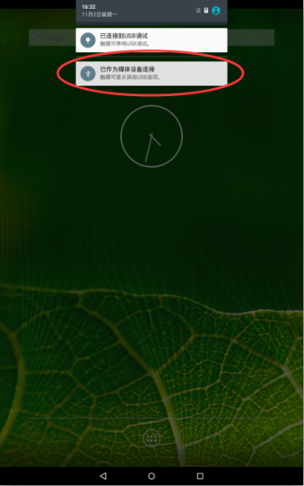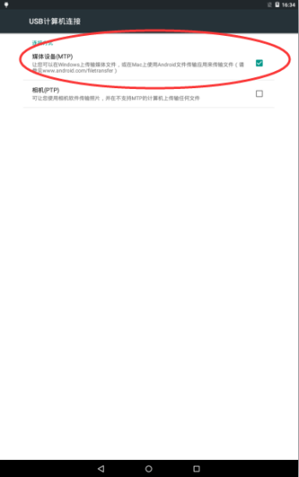
- 6.2 Tips of using Storage devices:
- Use USB cable to perform the copy and to remove files. Copy MP3 files to My Music folder, MP4 or AVI files to Videos folder, Photos files to DCIM folder.
- Attention: Do not unplug the port connected to the USB cable directly. Please exit first to prevent data loss.

